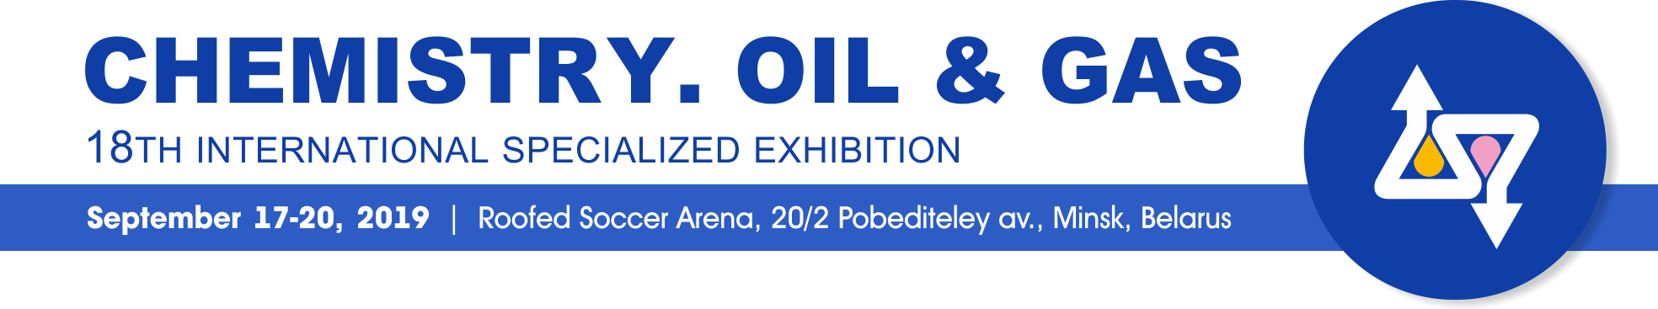
INFORMATIONAL LETTER

ABOUT THE EXHIBITION
International specialized Exhibition ‘Chemistry. Oil & Gas’ has been held in Minsk since 1994. It aims to inform specialists about the current state of the chemical technologies market, as well as to promote development of perspective scientific and technological innovations in chemistry, ecology, oil and gas extraction, processing and transportation industry.
As chemical, oil and gas complexes of Belarus are in close integration with CIS economy, and the Republic of Belarus is situated in the center of Europe, so the rate of interest to the Exhibition is always maintained at high level. For the years of the Exhibition performance more than 400 enterprises from Austria, Belarus, Belgium, Britain, Czech, Estonia, Finland, France, Germany, Hungary, Italy, Japan Kasakhstan, Latvia, Norway, Poland, Russia, US, Uzbekistan, Ukraine, Switzerland, Sweden took part in it. Many participants became the permanent exponents at the ‘Chemistry. Oil & Gas’ Exhibition.
Within the Exhibition a lot of conferences, seminars, ‘round tables’ are organized, where the topical issues influencing the dynamical development of the chemical, oil and gas complexes and supporting the competitive production manufacturing, are discussed.
Traditionally the Exhibition is visited by more than 3000 people. The most of them are specialists connected with the thematic of the Exhibition, heads of enterprises and branches, officials, foreign guests, diplomatic and international trade representatives, that creates the profitable business conditions.
PETROCHEMICAL COMPLEX OF BELARUS
More than 500 kinds of oil and petrochemical products are manufactured in Belarus. Belarusian petrochemical complex includes the enterprises dealing with oil extraction, refining and transportation, petroleum product supply, chemistry and petro chemistry, as well as the range of scientific, architectural and engineering, building, maintenance and commissioning organizations. This is one of the biggest and most strategic important complexes in the country.
The branch production is exported to 120 countries all over the world. More than 70 % of the petrochemical production is sold on external market.
You are invited to participate in the 18th international specialized Exhibition ‘Chemistry. Oil & Gas’!
The Exhibition is included in the business agenda of the Belarusian industrial forum - 2019, that has been held since 1994, and gained the image of the famous interstate Event.*
*For more information. ‘Belarusian industrial forum -2019’.
At the Exhibition will be performed: *:
• Current achievements in Chemistry;
• Chemical, oil, oil-refining and gas Industry equipment, raw materials, technologies and production;
• Computer-aided management systems of oil and gas extraction, collecting, transportation, storage and refining processes.
* For more information. ‘Exposition departments’.
Time and Venue:
September 17 – 20, 2019
Roofed Soccer Arena, 20/2 Pobediteley av.,
Minsk, Belarus
ORGANIZER
EXPOFORUM, Exhibition company
OFFICIAL SUPPORT
• Belarusian State Concern for Oil and Chemistry (‘Belneftekhim’ concern);
• the Belarusian national Academy of Sciences;
• Belarusian Chemical Society.
BUSINESS AGENDA
• Traditional seminar of academician Vladimir Agabekov;
• Belarusian industrial forum events;
• Presentations of exhibitors.
STATISTICS 2018:
• Exhibition participants: 32 companies, enterprises and firms from Belarus, Russia, Romania, Ukraine;
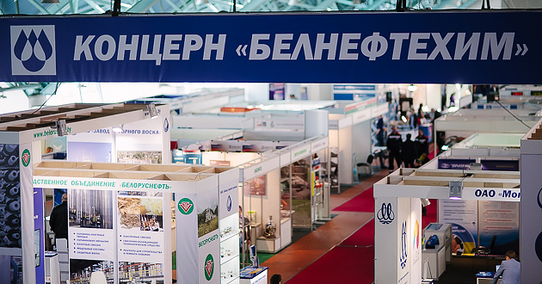
• more than 3000 specialists visited the Exhibition.
THE COST OF PARTICIPATION for foreign exponents*.
*Prices in EUR, VAT excluded.
• Registration fee 190 EUR + VAT
• Unequipped space 60 EUR/m² + VAT
• Equipped space 87 EUR/m² + VAT
Discounts:
  - With the order more than 24 sq. m of exhibition space inside the pavilion;
  - If you perform the working sample of large-size equipment item in the exhibition pavilion.
*For more information ‘GENERAL TERMS OF PARTICIPATION for foreign exponents’ and Application forms
ORGANIZER ADDRESS
EXPOFORUM, Exhibition company
91 Pritytskogo str., office 432
Minsk 220140 Belarus
Tel/Fax: +375 17 314 34 30, expoforum.by.
CONTACTS
тел./факс: (+375 17) 314 34 38
Nicolaévich Alexander
Head of international department,
e-mail: global@expoforum.by;

